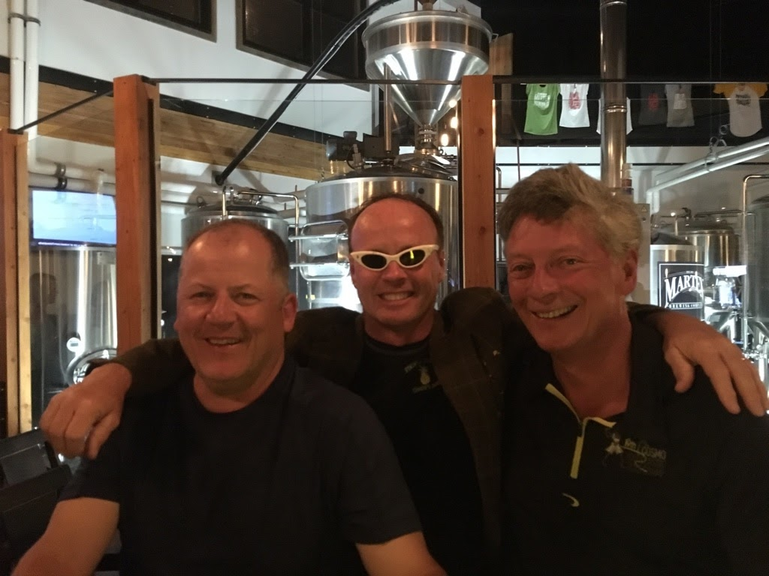
Len "Sloaner" Sloan 97 & 00 Champ  2018 Result: 215 11th  The Grand Poohbah could very well set several records this year if all of his wildest dreams come true? His 25 consecutive appearances is one he holds alone, but the one he really wants is the “Most years between victories” record that “Batman” currently holds at 13. A third green jacket for the Sloaner would be an epic comeback that would make Tiger’s recent first Masters in 14 years seem like a 3-game goalless drought to the man who has witnessed 18 guys don the Jacket since 2000! The pressure to win in the 21st century is obviously weighing on the “GPB” as he recently took up the relatively unknown sport of hedge-surfing and had a hissy in Arizona when the boys hid his Canary Yellow swim trunks? However, the Sloaner does have a new roommate who has found his missing Mojo, so watch out Whistler, it’s Hammer time?  Odds: 3-1 25th Consecutive appearance. | Jamie "Tender" Stoddard 2018 Champ  2018 Result: 201 1st  All hail the “Champ”! Some of our readers may have been in a Cryogenic induced Coma the past decade and have about as much faith in “Tender” being the holder of the Green Jacket as Donald Trump occupying the Oval Office? But it did happen, in a one hole playoff versus 2016 Champ Dumer that had as many miscues in one hole as the “Batman”-“Sloaner” 2013 three hole playoff duel in the Desert. Many wondered if Teetotaler Tender would be able to celebrate his first Green Jacket with flair, but the Jacket has been on a BC wide tour that has somehow rekindled its former glory. A potential conflict of interest inquiry was recently diverted as the 4C’s have announced that the “Champs” Cosmo Cap will plummet a full 8 strokes (23 to 15) which will reduce the chances of a repeat to next to zero?  Odds: 25-1 24th Consecutive Appearance
Wes "Hennigar" Pederson 99,03,09 Champ  2018 Result: 213 10th  Two consecutive 10th place showings might have the Las Vegas odds-makers steering clear of “Hennigar” but there is a definite edge to the Frozen Paddle CEO that has the Cosmo Insider going all in on Henny this year (Before we all get on the Henny bandwagon, when a back 9 40 would have got him in the Playoff, he did go 10-4-8 on holes 10-12 [9-over] when in contention in the final round):  - His reconstructed knee has brought back 25 yards off the tee and 5 more fairways per round?  - The Official Cosmo Rule Ruler is the only one who actually understands the new rules?  - He’s the Only Player to EVER win in a year ending in “Nine”!  Add to this having the guts to call out the current “Champ” on a post and out ruling in Maui has the three-time Stud ready and willing to keep the Jacket in the extended family for one more year!  Late breaking news from Aberdeen indicates “Hennigar” may have the Chip-Yips, beware!  Odds: 5-1 20th Appearance | Billy “The Kid” Kennedy 2001 Champ  2018 Result, 209 5th  Trying to keep track of “The Kid’s” current employer is like trying to understand his backswing mechanics? But, we’re just “Kidding” Billy, whatever floats your boat, as his second consecutive top 5 shows it’s working. “The Kid” did tail off a bit in the final round last year as he was only 1 back entering the final round. Triples on 6 and 7 threw his Championship hopes off course and a pair of hockey sticks on the back relegated him to a close but no cigar result. However, rumour has it that his recent switch from insurance adjuster to financial adviser will have him playing more conservatively as nobody can overcome that kind of carnage (unless you have a Melon like Cosmo Cap) that late in a tournament.  Odds: 17-1 20th Appearance

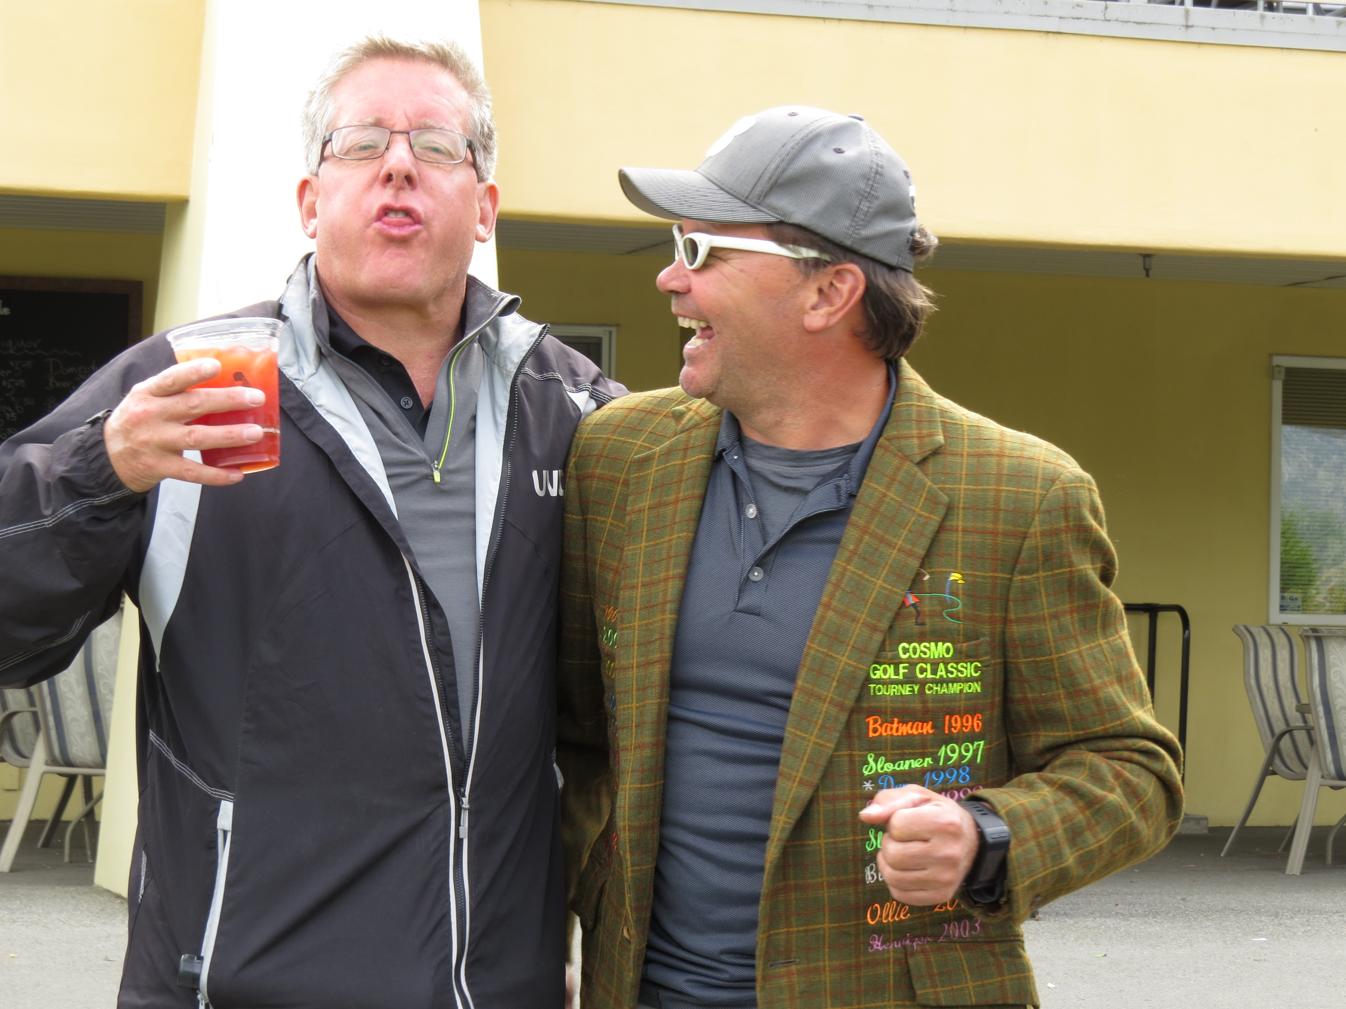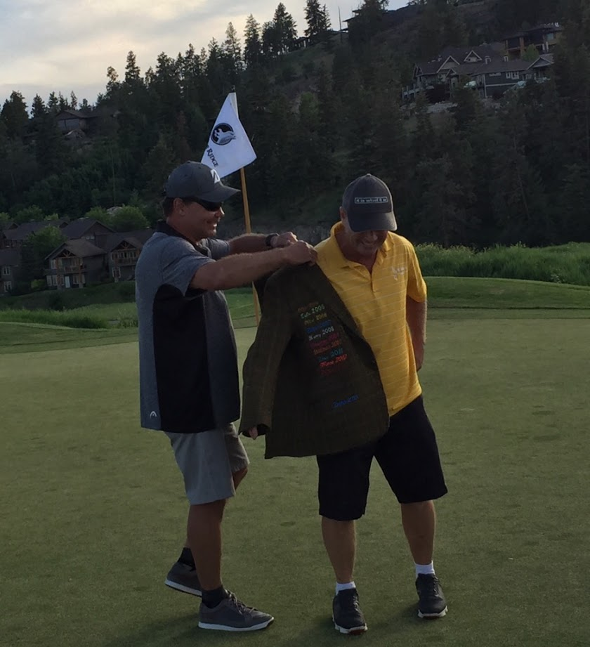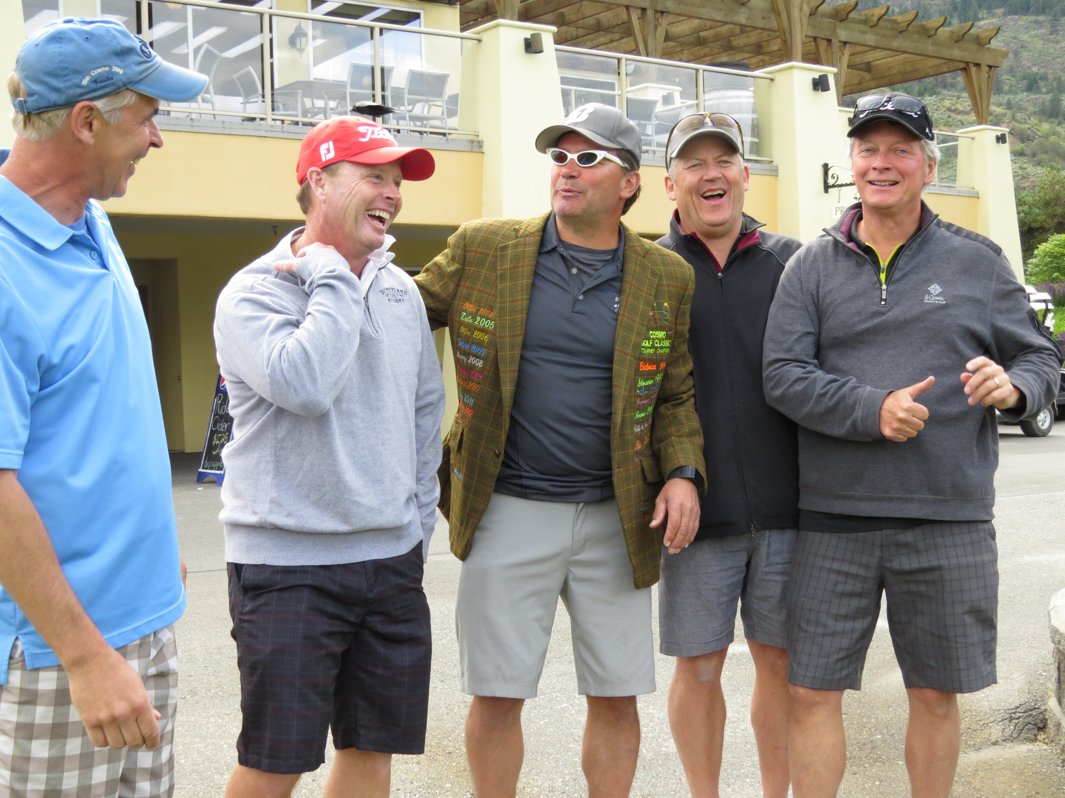
Russ "Rusty" Young  2018 Result: 209 5th  After 23 long years of futility, Rusty is poised to end the current longest losing streak of 22 years without a Jacket. The fact that Champ “Tender” was excused from his and Rusty’s “No jacket until we’re 70” pact last year should allow him to challenge on the weekend. Add to this the recent news that his daughter Hannah has been accepted into Medical school will surely allow the six inches between his ears to purr like a kitten all the way home. In the event that his Crown Royal IV malfunctions, Hannah has volunteered to perform her first full frontal lobotomy on her Dad in exchange for four years of tuition? Although the return to Whistler has several former Mountain Champs licking their lips, that can’t be said for Rusty especially on the Chateau course. An inspection of his last 3 Whistler appearances show 15th (last), 13th and 9th placings which can be directly linked to an average gross score of 97 on Chateau.  Odds: 11-2 23rd Consecutive Appearance. | Rick "Zulu" Zawada 2005 Champ  2018 Result: 224 13th  The final player to confirm their attendance in the Silver Anniversary event is hoping that there are no frost warnings as the shape of water on his elbow is still a little “Tender”. This injury is being blamed on a blind side hit in the Goldpanners tournament, but it very well may be the residual effects of a week of arm curls in the Arizona desert? Whatever the case, look for “Zulu” to hit three 5-irons on most par 5’s which is especially wise on Purgatory (#4 on Big Sky). His ability to turn water into wine and frowns upside down makes “Zulu” a favourite playing partner, but he has shown that his dance moves at Buffalo Bills can translate to some equally impressive long irons on the links.  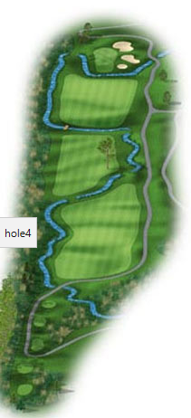  Odds: 56-1 17th Appearance
“Markie” Mark Courtney  2014 Result 274, 5th  The return of the two Mark’s means one thing, as soon as they address their ball their backswing will occur faster than you can say “Quick Draw McGraw”. The “Markie” Mark portion of that habit needs to be quick as he is so busy making money that he needs to recalibrate the weight of his wallet after every swing! It’s hard to believe that it’s been 5 long years since we’ve seen his lovely legs, which means it’s been 5 years since the Osoyoos Oddity when Mark and Rusty both aced #13 on Friday the 13th within 13 minutes of each other!  But have no fear of that kind of miracle occurring this year as “Markie” has only played a half dozen times the past 2 years.  Odds: 13-1 4th Appearance | Richard “Doc” Dougherty 2011 Champ  2018 Result 212,8th  “Doc” and Whistler, “Doc” and Whistler, “Doc” and Whistler, “Doc” and Whistler. Thanks to “Doc’s” Doctor prescribing a memory reduction therapy after the “collapse” in 2007, “Doc” only remembers half of his Whistler Cosmo’s. Luckily for him, he can remember up to 7 PM on Saturday the year he won and the previous year when “Batman” won but has no idea why/how “Dano” has his name on the Jacket twice? Seeing how it’s been 9 years since we have played the Whistler Palmer course, fair warning to his cart mate on Thursday and Friday for a barrage of questions regarding a wide-ranging array of topics. With his game slowly rounding into form, look for “Doc” to challenge early until he realizes his 2nd Jacket isn’t worth the risk of a choppy boat ride on Sunday morning or a frosty wife on Sunday afternoon!  Odds: 7-1 14th Appearance.

